**Time Series Visualization**

**R. Harini**

**18BCE1010**

**Dataset:** <https://www.kaggle.com/sudalairajkumar/covid19-in-india?select=covid_19_india.csv>

**Tools used:** MS Excel, Tableau and Python

**Confirmed Cases**

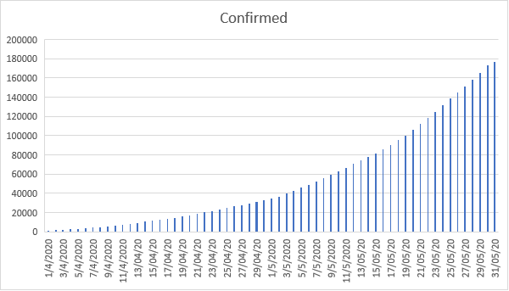

**Deaths in India:**

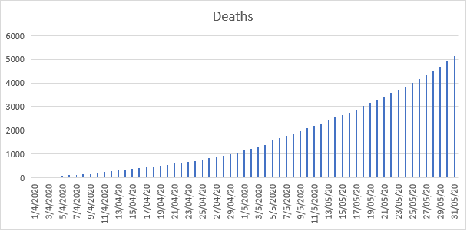

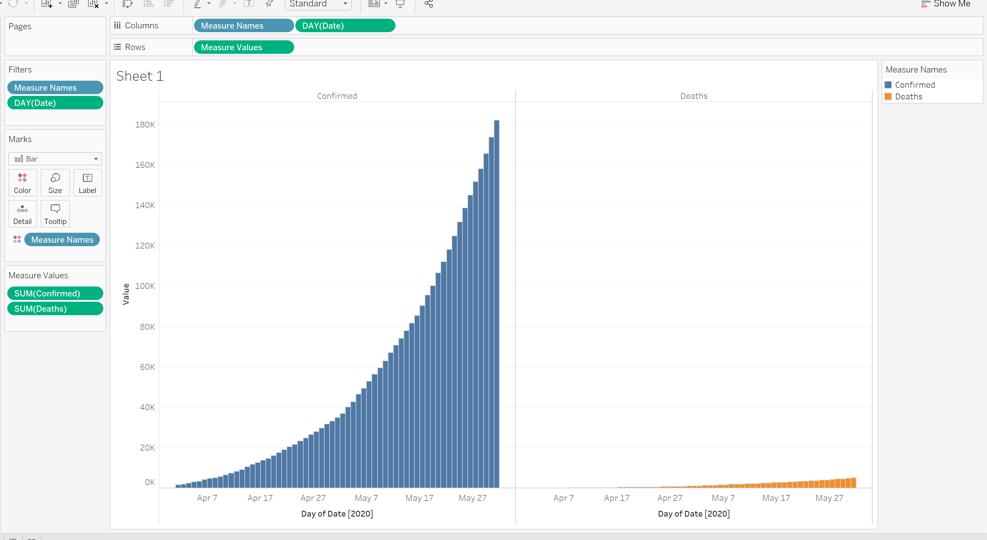

**For prediction:**

